# 

**University Of Engineering and Technology, Lahore**

**Digital Marketing**

**Assignment:**

Topic: Digital Presence of FoodPanda

**Presented By:**

Name: Marryam Abid

Reg. No: 2021-BBIT-50

Section: A

**Submitted To:**

Miss. Maham

Contents

1. Introduction 3

1.1 History 3

1.2 Vision, Mission and Values 4

1.2.1 Vision Statement 4

1.2.2 Mission Statement 4

1.2.3 Core Values 4

2. Food Panda’s Business Model 5

2.1 Food panda’s Timeline 5

2.2 How Does Food Panda Work? 6

2.3 Value Proposition 7

3. Digital Presence of Food Panda 8

3.1 Food panda's Digital Engagement Strategy: 8

3.1.1 User-Centric Website 8

3.1.2 Foodpanda App with New Features: 8

3.2 Promotional Campaigns of Food Panda 9

3.2.2 World Hunger Day: 9

3.2.3 Celebrating The National Days 10

3.2.4 Collaboration with Games 10

3.3 Social Media Presence of FOODPANDA 10

4. Strategic Analysis of Food Panda 11

4.1 Food Panda’s SWOT Analysis 11

4.1.1 **S**trengths 11

4.1.2 **W**eaknesses 12

4.1.3 **O**pportunities 12

4.1.4 **T**hreats 12

5. Online Branding of Food Panda 13

5.1 Brand Story of FOODPANDA 13

5.1.2 Mystery Behind the Food Panda’s Logo 13

5.2 Brand 13

5.2.1 Brand Voice 14

5.2.2 Brand Personality 14

5.3 Marketing campaigns run by FOODPANDA 15

5.3.1 Deals and Special offers 15

5.3.2 The discount campaigns 15

5.3.3 Partnership campaigns 15

5.3.4 Seasonal Campaigns 15

5.4 Food panda's Tik Tok presence: to encourage engagement and awareness of the Brand 15

6. Revenue Model of Food panda 16

6.1 How Food Panda Makes Money 16

6.1.1 Registration Fees 16

6.1.3 Delivery Charges: 16

6.1.4 Commission from Restaurants 17

6.1.5 Affiliate Income 17

6.1.6 Subscription 17

7. Conclusion 18

8. References 19

# 

# 1. Introduction

Food panda is an online food and grocery delivery platform owned by **Berlin-based Delivery Hero**. Food panda operates as the lead brand for Delivery Hero in Asia, with its headquarters in Singapore. It is currently the largest food and grocery delivery platform in Asia, outside of China, operating in 11 markets across Asia (“Foodpanda,”2024).

## 1.1 History

In **2012**, Swiss Lukas Nagel and Rico Wyder established Food panda in Singapore, before expanding to Malaysia, Indonesia, the Philippines, Taiwan and Thailand (“Foodpanda,”2024).

Food panda was launched in Singapore in March 2012 and expanded to 16 countries by the end of the year. It then expanded to seven more countries and had its presence in 23 countries by February 2013 (Kumar & Bajj, 2023).

A year later in **2013**, Food panda was launched in Bangladesh and Romania. With more than 20,000 employees operating in their company, Food panda became the largest food delivery service in Bangladesh. In **2014**, the service expanded into the Balkans, Brunei, as well as the Philippines. In February 2014, Food panda acquired Eat Oye, a rival company in Pakistan. Global expansion of the Food panda business was led by Ralf Wenzel, Felix Plog and Ben Bauer (“Foodpanda,”2024).

By **2016**, none of the original managing directors or co-founders remained with the company. Its operations in Indonesia also shut down due to competition from flourishing app-based taxi-motorbike services, while the company sold its Delivery Club business in Russia to Mail. Ru for $100 million in November 2016 (“Foodpanda,”2024).

On 1 November **2017**, Food panda re-branded and changed its brand color from orange to pink with an updated logo across all served countries, following its acquisition by Delivery Hero. From **2019 to 2020**, Food panda began operating in other markets in Southeast Asia, launching in Thailand, Myanmar, Cambodia, and Laos. Food panda was also launched in Japan in September 2020 (“Foodpanda,”2024).

Since **2021**, Food panda has partnered with home chefs through an initiative called Home Chefs. The initiative began in Pakistan after the company noticed that there are a lot of female home chefs looking for side income, but it has since scaled to Bangladesh and Malaysia.

In early **2022**, Food panda announced its new mascot called Pau-Pau, A humanistic panda that cares about empowerment and environment. The new mascot will be rolled out across all of Asia. In August 2022, Food panda is collaborated with digital investment platform Syfe (“Foodpanda,”2024).

## 1.2 Vision, Mission and Values

### 1.2.1 Vision Statement

Food Panda with its broad vision is now accomplishing its business almost 60 plus countries. Its Vision is:  
**“To bring good food into your everyday”**

("Food panda Mission," n.d.)

### 1.2.2 Mission Statement

Every Company has a mission to achieve its business goals. As Food Panda is an E-Business, it’s also having a mission:

**“To not just deliver, we bring it always going the extra mile to make your experience memorable.”**

("Food panda Mission," n.d.)

### 1.2.3 Core Values

The core values of Food Panda show its customer loyalty and They take risks for the betterment of their business. learn from mistakes, keep iterating, and always focus on execution. (“Food Panda,” n.d.).

* 1. Some Interesting Facts & Figures About Food Panda

**$100 Million from Rocket Internet and other investors.**

**$6 billion+**

**August 2012**

Funding

Valuation

**Lukas Nagel & Rico Wyder**

Founders

Founded In

Headquarters

**Berlin, Germany, Singapore**

# 2. Food Panda’s Business Model

As Uber's business model grew in popularity, the concept of on-demand apps became viable and popular. Food panda is one of the most popular on-demand food and delivery platforms on the market. It is a professional service that delivers food from nearby restaurants to customers' doorsteps (Nirav Parmar, 2024).

Today, businesses often choose the application solution that will help them meet their business needs. Food products in the on-demand industry are prone to psychological problems. They promise to save end users time and effort. Revenue in food distribution is expected to grow and reach $1.02 trillion by 2024 (Nirav Parmar, 2024).

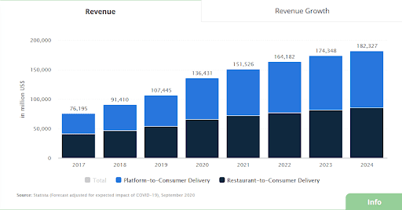

## 2.1 Food panda’s Timeline

***Have a Quick Look Over the Success History of Food Business Giants!***

Food panda is operating in more than 50 countries. Works in Bulgaria, Asia Pacific and Romania. The platform allows food lovers to order their favorite, dishes from local restaurants. Food panda has partnered with more than 115,000 restaurants in approximately 246 cities. Food panda started to offer special discounts on the platform and increase its traffic, completing approximately 300,000 orders per day. In 2019, this number increased to 5,000 orders per day (Nirav Parmar, 2024).

## 2.2 How Does Food Panda Work?

Food panda is an impressive platform that helps eateries to offer excellent service to a wide range of customers who want to get their food delivered to their doorsteps. The company generates profit through delivery fees it decreases its operational cost by following some effective methods:

* Offer discounts for bulk purchases
* Build a higher network to deliver food on time
* Collecting cash before delivery
* Advertisement fees

As a result, more and more businesses are considering investing in on-demand solutions. Take a look at what Food panda does to deliver products to customers' doorsteps on time.

2.2.1 Steps How food panda works

**Step 1:** Food lovers explore the list of nearby restaurants and menus to order mouth-watering dishes from them.

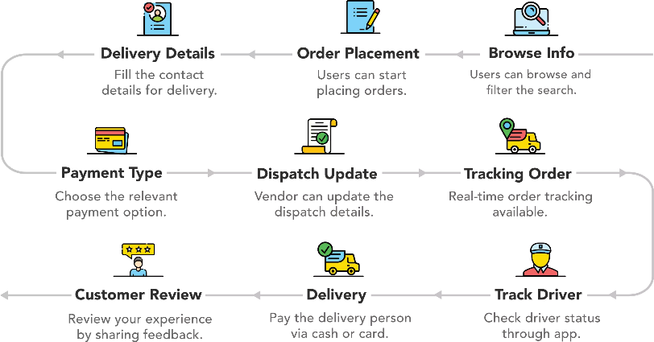**Step 2:** Restaurants receive an order and prepare food

**Step 3:** Prepared order is handed over to delivery providers

**Step 4:** The delivery provider delivers the meals to the customer’s place

**Step 5:** Customers make payments and provide feedback according to their experience gained.

* 1. Customer Segments

1. 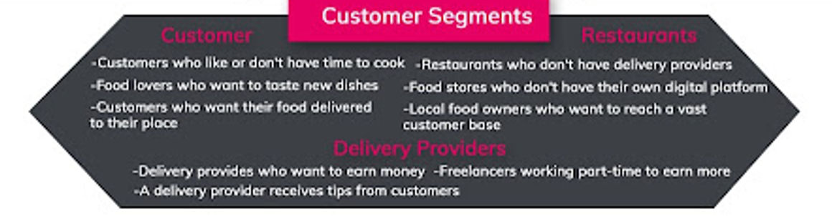Consumers b) Restaurants c) Delivery Providers

## 2.3 Value Proposition

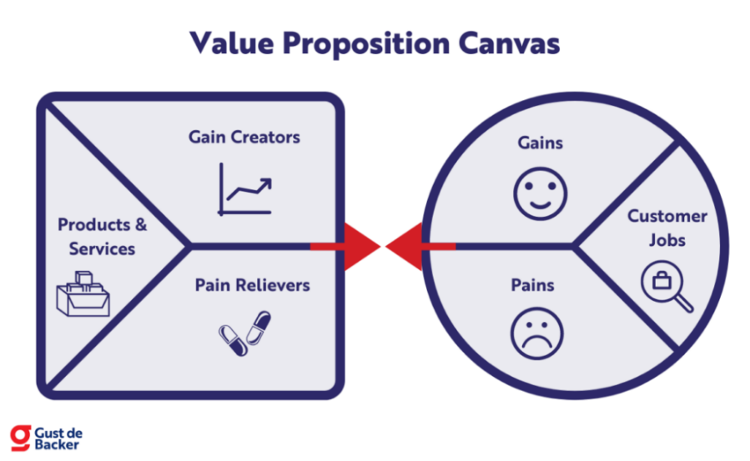The platform has key features such as **convenience, accessibility, personalization, status, and discounts**. Food panda creates accessibility by allowing food retailers to market their business to customers who do not want to visit physical stores and have difficulty finding places online makes it easier for customers to place orders with advanced solutions. They can place orders through the platform 24/7 without any problems. Customers can also pick up their order or have it delivered to their door (Nirav Parmar, 2024).

Food panda has also received some major national awards, such as the "Best E-Commerce Startup" award at the 2014 European Technology Startup Awards (Nirav Parmar, 2024).

# 3. Digital Presence of Food Panda

Foodpanda is a well-established online food delivery service that has a significant digital presence in the food industry. It operates in over 40 countries worldwide and has a vast network of 35,000 restaurants ("Foodpanda Market Analysis,” n.d.).

## 3.1 Food panda's Digital Engagement Strategy:

Analyzing the various online channels utilized by Foodpanda to interact with customers:

### 3.1.1 User-Centric Website

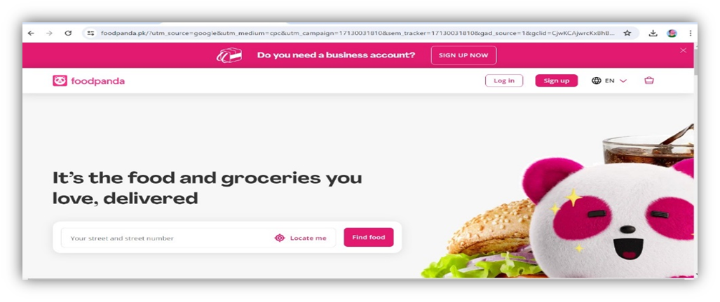Ordering food from a variety of restaurants has been made easy through the Foodpanda website:

This is how Foodpanda works:

* Find a restaurant by entering the location.
* Users can order desired items from the restaurant's menu.
* After adding items to the cart, the user can proceed to Checkout & Payment.
* Once confirmed, an SMS is sent to users and delivery is promptly made. (Foodpanda, 2024)

### 3.1.2 Foodpanda App with New Features:

* **Monitor Your Order**

You can receive up-to-date information on the status of your food delivery in real-time. (Foodpanda, 2024).

* **Refreshed User Interface:**

The app enhances your browsing and ordering experience, allowing you to do so at a faster pace (Foodpanda, 2024).

* **Special Offers:**

You can cut your expenses by taking advantage of discounts, voucher codes, and coupons (Foodpanda, 2024).

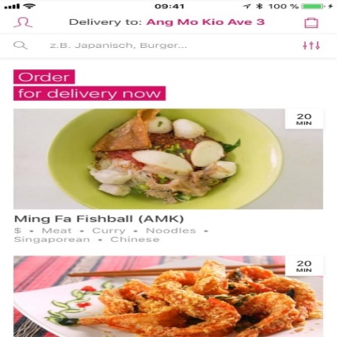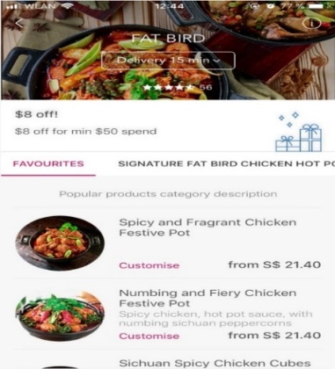

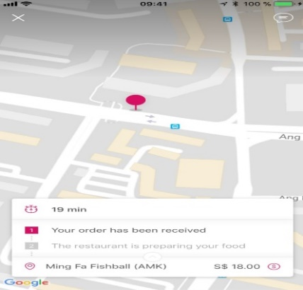Images of Food Pand’s App features

## 3.2 Promotional Campaigns of Food Panda

3.2.1 Sharing Happiness On Religious Events

Food Panda initiated a charitable campaign named "Click Donate" that allowed customers to donate a specific amount with each order. (Shafiq Siddiqui, 2014)

### 3.2.2 World Hunger Day:

Foodpanda introduced a new meal donation feature of donation in Asia, to encourage the United Nations World Food Programme. This initiative launched on the occasion of World Hunger Day 28 May 2022. (Foodpanda, 2024).

### 3.2.3 Celebrating The National Days

On Pakistan’s Independence Day i.e., 14th August 2014, Food Panda offered great deals and offers to its users and customers – everyone simply loved it and availed of the offers (Shafiq Siddiqui, 2014).



### 3.2.4 Collaboration with Games

Foodpanda recently launched a successful marketing campaign on social media based on FIFA which ultimately resulted in a successful outcome that left the entire team feeling happy and content (Shafiq Siddiqui, 2014).



## 3.3 Social Media Presence of FOODPANDA

Company launched a premium subscription program in 2021, providing clients with a range of incentives. Customers pay a monthly cost that varies according on their country of residence. In exchange, consumers can enjoy a variety of privileges, including a limited number of free delivery, various discounts, and many more.

# 4. Strategic Analysis of Food Panda

When we study and do research on a Business either it’s a physical Business or an E-Business, it’s necessary to do the strategic analysis to understand the performance and existence of the business like where it stands in the market place. We can do Strategic analysis by using multiple methods But I will cover Food Panda’s analysis using **SWOT** analysis and **PESTEL** analysis.

## 4.1 Food Panda’s SWOT Analysis

SWOT analysis will cover the Internal factors (Strengths, weaknesses) and external factors (Opportunities and Threats) of Food Panda. These attractive representations will better explain the SWOT analysis.

**Threats**

* Increasing Competition
* Changes In Economic Condition
* Ease Of Visiting Nearby Restaurants

**Weaknesses**

* Orders From Nearby Restaurants
* Tap On Free Delivery
* Coverage

**Opportunities**

* Growing Market
* Customer Expansion

**Strengths**

* Excellent Platform
* Strong Brand Name
* Great Customer Support

**T**

**O**

**W**

**S**

### 4.1.1 **S**trengths

* **Strong brand name**

Food panda was hold over by the firm *'Delivery Hero'* in the year 2016. Delivery Hero manages several international brands. It handles *Foodora, HelloFood, Delivery Club, and many others besides Food panda*. Hence, Food panda is under the shadow of a strong brand (Kumar & Bajj, 2023).

* **Excellent Platform**

Food panda is known for its powerful and user-friendly website and mobile app. Food lovers can use these platforms to order meals without any difficulty. They can search from a wide list of restaurants. Moreover, customers can track the entire process from placing the order to receiving the delivery (Kumar & Bajj, 2023).

### 4.1.2 **W**eaknesses

* **Orders From Nearby Restaurants**

Orders are available only from restaurants that are located in the same location as the delivery address. This restricts the customers from trying out various restaurants. Sometimes they want to go outside to enjoy the food so they cannot restrict them to purchase online (Kumar & Bajj, 2023).

* **Coverage**

Food panda covers the selected cities for working and delivery within a country. So, it can be the drawback (Kumar & Bajj, 2023).

### 4.1.3 **O**pportunities

* **Growing Market**

Food panda competes in a segment that continues to grow. Hence, there is immense scope for improvement (Kumar & Bajj, 2023). Food panda is growing in several cities that will give the opportunity of jobs to the unemployed residence of the specific city.

* **Customer Expansion**

Food panda should tie up with new restaurants and update its website or app to attract foodies (Kumar & Bajj, 2023). As Food panda is growing very fast in multiple countries so customer base also increases.

### 4.1.4 **T**hreats

* **Increasing Competition**

The list of startups and established businesses with online food delivery segment is increasing day by day (Kumar & Bajj, 2023). If Food panda will take initiative with the rapidly changing technology, then it will stand in their competitors.

* **Changes In Economic Conditions**

Economic changes can crush even the best. Food panda needs to build high Standard to withstand rough times (Kumar & Bajj, 2023).

# 5. Online Branding of Food Panda

### 5.1 Brand Story of FOODPANDA

5.1.1 Mystery behind Food Panda’s Name

It is very crucial to suggest a brand name and necessary to do preliminary research about the meaning of your brand name. If your Brand name consists of some special words, make sure it should reflect your business idea. So, the reasoning behind the name of food panda is here:

The inclusion of "**Food**" in the name clearly indicates that the company is related to food delivery or food services. This straightforward association helps potential customers immediately understand the nature of the business.

The addition of "**Panda**" injects a sense of playfulness and friendliness into the brand.“Pandas” are often seen as cute and approachable animals, which could help create a positive and memorable impression on customers.

### 5.1.2 Mystery Behind the Food Panda’s Logo

 Explaining this mystery by introducing **3 whys** is more effective.

**Why they choose the MASCOT type?**

The Mascot logo of Food panda adds a playful and memorable element, enhancing brand recognition and conveying a friendly image to customers.

**Why the shape of Panda?**

The panda in the Food panda’s logo symbolizes friendliness and approachability.

**Why chooses these colors?**

Fuchsia pink and white

Pink is often associated with qualities like warmth, friendliness, and playfulness, which could align well with Food panda's goal of providing a convenient and enjoyable food delivery experience

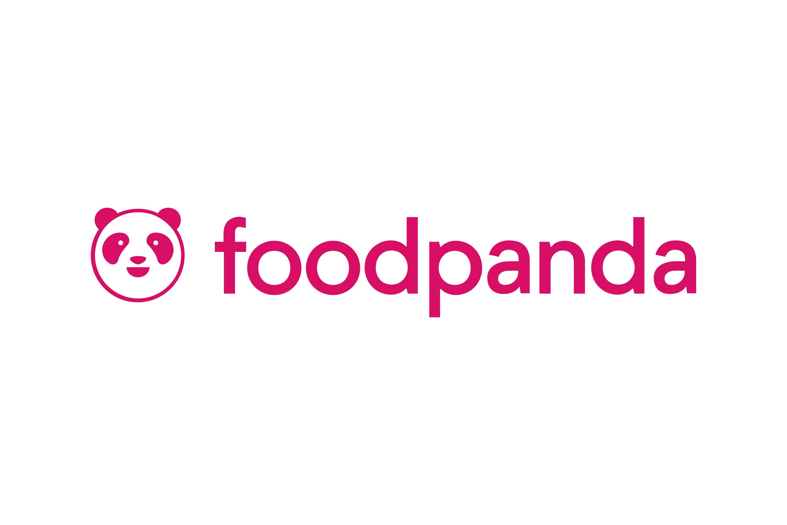

5.2 Brand Identity of FOODPANDA

As a reliable and convenient food delivery platform, Foodpanda has built its reputation in Pakistan.

### 5.2.1 Brand Voice

Wherever Life takes you

Food panda's brand voice is casual, friendly, and conversational, resonating with its target audience of young, urban consumers. In order to connect with customers, the brand communicates in a relatable way through colloquial language and engaging content. Food panda invites customers to embrace a carefree and happy lifestyle in line with the playful nature of its brand mascot by using the slogan

### 5.2.2 Brand Personality

Food panda's brand personality, which is friendly, approachable and relatable, reflects "living like a panda". The slogan stresses the fact that Food panda is more than just a food delivery service; it's a lifestyle brand.

“Live like a Panda”.

 To commemorate this milestone, food panda launched its brand philosophy which encourages people to ‘live like a panda’, meaning freeing up their time and energy to pursue what really matters to them.



**Pau-Pau** was introduced during a time when food delivery was undifferentiated with deals and discounts to personify the food panda brand and make it more relatable to people’s everyday lives. Since his debut, Pau-Pau has received immense love from millions of people across the region.

## 5.3 Marketing campaigns run by FOODPANDA

### 5.3.1 Deals and Special offers

In addition to discounts, Food panda runs special deals and offers to incentivize customers to order from the platform. These deals may include buy-one-get-one-free (BOGO) offers, meal bundles at discounted prices, or exclusive promotions in partnership with specific restaurants.

### 5.3.2 The discount campaigns

In order to attract customers and raise the volume of orders, Food Panda is frequently offering discounts on orders. Such discounts may include different forms, such as a percentage discount on the total order value, flat discounts for specific items or categories and promotional codes to be used by either new or existing use.

### 5.3.3 Partnership campaigns

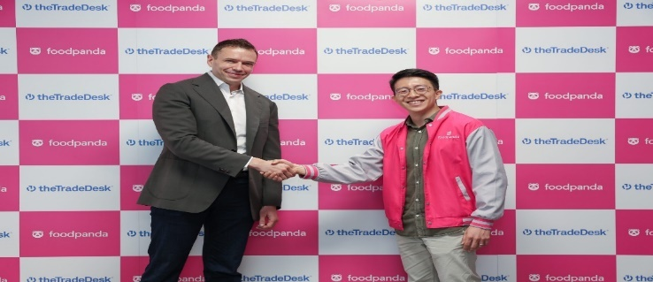Food panda is working with restaurants and food brands to start a common marketing campaign. To attract customers, such campaigns may include cobranded advertisements, social media contests and special menu promotions.

### 5.3.4 Seasonal Campaigns

Seasonal marketing campaigns related to holidays, festivals and special occasions are carried out by Food panda. In order to promote the ordering of food in these periods, such campaigns take advantage of the holiday spirit and provide thematic promotional offers.

### 5.4 Food panda's Tik Tok presence: to encourage engagement and awareness of the Brand

Through continuous technological advancements and service enhancements, Food panda remains competitive, catering to the evolving needs of customers and restaurant partners. To further strengthen its market leadership in the Philippines, Food panda focuses on driving efficient cost per acquisition through strategic advertising on Tik Tok while prioritizing user experience improvements.

# 6. Revenue Model of Food panda

## 6.1 How Food Panda Makes Money

Food Panda generates revenue from other sources, allowing the corporation to generate significant profits. The food ordering and delivery market generated around **US$7.4 billion** in 2021, this profit increased by 40% year-on-year.

Food Panda sector revenue grew by 60% as a result of the COVID-19 epidemic, compared to US$616.2 million in the same period last year. Food panda has seen a great increase in revenue in recent years.

### 6.1.1 Registration Fees

Digitalization has increased the craze of getting food delivered right to their doorsteps. Rather than restaurants and cravings nowadays, food lovers love to leverage the custom home delivery facility. Foodpanda eliminates extra initiatives to manage and find delivery services. Foodpanda changes approximately $100 to $150 for the registration (Nirav Parmar, 2024).



6.1.2 Advertisement

Foodpanda charges advertisement fees from brands. It enables restaurants to advertise their business on the platform (Nirav Parmar, 2024).

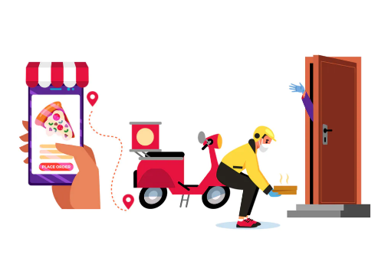

### 6.1.3 Delivery Charges:

Food panda charges fees on every delivered order; delivery charge cost entirely depends on delivery location (Nirav Parmar, 2024).

### 6.1.4 Commission from Restaurants

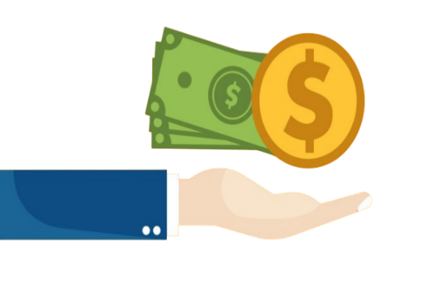Foodpanda normally charges a commission rate of 15% to 25% of the order value, including all taxes. These rates are not fixed and might vary depending on numerous factors.

Foodpanda claims around 20% commission on every order that customers place through the platform. Besides commission, restaurants don’t need to pay the place rent, electricity bills, and other service costs; this ensures great profit-making for the platform (Nirav Parmar, 2024).

### 6.1.5 Affiliate Income

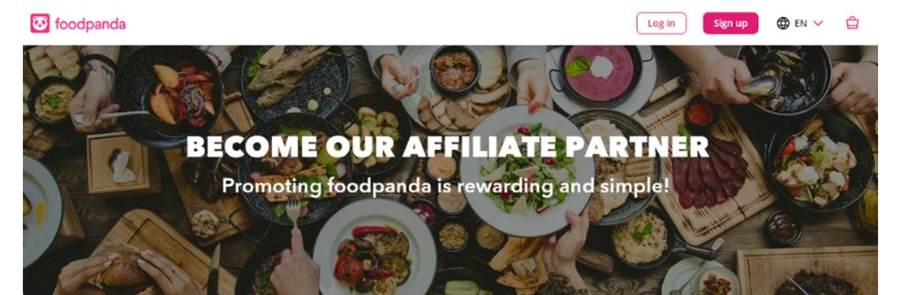Foodpanda has diversified its revenue streams through affiliate marketing and agreements with financial institutions, which is a smart move in the competitive meal delivery business. Foodpanda participates in affiliate marketing networks that pay commissions for recommending credit cards supplied by various banks.

### 6.1.6 Subscription

Company launched a premium subscription program in 2021, providing clients with a range of incentives.

Customers pay a monthly cost that varies according on their country of residence. In exchange, consumers can enjoy a variety of privileges, including a limited number of free delivery, various discounts, and many more.

# 7. Conclusion

In conclusion, the project report has provided a comprehensive overview of Food panda, highlighting its vision, mission, core values, brand identity, customer segments, value proposition, online branding, strengths, weaknesses, opportunities, and threats.

Food panda has a vision to bring good food into everyday life, along with its mission to go the extra mile for memorable customer experiences, showcases its commitment to excellence in the food delivery industry. The core values of owning challenges, taking risks, and staying humble represents the company's dedication to continuous improvement and customer satisfaction.

The brand identity of Food panda, characterized by a casual and friendly brand voice, a relatable brand personality, and the slogan "Live like a Panda," resonates well with its target audience and sets it apart as a lifestyle brand rather than just a food delivery service.

Moreover, the report delves into customer segments, highlighting the platform's key features such as convenience, accessibility, personalization, and discounts, which contribute to its success in the market. The recognition received by Food panda, such as the "Best E-Commerce Startup" award, further solidifies its position as a leader in the industry.

While Food panda boasts an excellent platform with a user-friendly website and mobile app, there are areas for improvement, such as expanding coverage to more cities and offering orders from a wider range of restaurants to cater to diverse customer preferences.

Looking ahead, Food panda faces opportunities for growth in a rapidly expanding market and the chance to expand its customer base by partnering with new restaurants and enhancing its digital platforms. However, it must also navigate threats such as increasing competition and economic fluctuations to maintain its competitive edge.

Overall, Food panda's strategic vision, strong brand identity, customer-centric approach, and continuous innovation position it well for sustained success in the dynamic and competitive food delivery industry.

# 8. References

Foodpanda. (2024). In Wikipedia. Retrieved April 27, 2024, from <https://en.wikipedia.org/wiki/Foodpanda>

Startuptalky. (n.d.). Foodpanda Business Model - How Foodpanda Works? Startuptalky. Retrieved Month Day, Year, from <https://startuptalky.com/foodpanda-business-model/>

Foodpanda. (2024). In Wikipedia. Retrieved April 27, 2024, from <https://en.wikipedia.org/wiki/Foodpanda>

Comparably. (n.d.). Foodpanda Mission. Comparably. Retrieved Month Day, Year, from <https://www.comparably.com/companies/foodpanda/mission>

Foodpanda. (n.d.). About Foodpanda. Retrieved April 27, 2024, from <https://www.foodpanda.com/about-foodpanda/>

Foodpanda Market Analysis. (n.d.). Osum. Retrieved from <https://blog.osum.com/foodpanda-market-analysis/>

Foodpanda. (2024). Foodpanda. Retrieved from <https://www.foodpanda.pk/>

Foodpanda. (2024). How it works. Retrieved from <https://www.foodpanda.pk/contents/how-it-works>

DSIM. (2023). Case study: How Foodpanda leveraged digital marketing to become Google of online food industry. Retrieved from <https://dsim.in/blog/case-study-how-foodpanda-leveraged-digital-marketing-to-become-google-of-online-food-industry/>

Foodpanda. (2024). Apps. Retrieved from <https://www.foodpanda.pk/contents/apps>

Foodpanda. (2024). Foodpanda Pakistan [Facebook page]. Retrieved from <https://www.facebook.com/foodpanda.pk/>

Foodpanda. (2024). Foodpanda Pakistan [Instagram profile]. Retrieved from <https://www.instagram.com/foodpanda_pakistan/?hl=en>

Shafiq Siddiqui. (2014). Foodpanda excels in digital marketing. Retrieved from <https://www.shafiqsiddiqui.com/foodpanda-excels-in-digital-marketing/>

Foodpanda. (2024). A spotlight on World Hunger Day 2022. Retrieved from <https://www.foodpanda.com/newsroom/a-spotlight-on-world-hunger-day-2022/>

AB Tasty. (n.d.). Email Remarketing Campaigns. AB Tasty. Retrieved Month Day, Year, from <https://www.abtasty.com/blog/email-remarketing-campaigns/>

Startuptalky. (n.d.). Foodpanda Business Model - How Foodpanda Works? Startuptalky. Retrieved Month Day, Year, from <https://startuptalky.com/foodpanda-business-model/>

Smith, White. (n.d.). Foodpanda Business Model: How Foodpanda Works & Makes Money. Codementor. Retrieved n.d., from <https://www.codementor.io/@smithwhitelabelfox/foodpanda-business-model-how-foodpanda-works-makes-money-1wb2eizdew>

Startuptalky. (n.d.). Foodpanda Business Model. Startuptalky. Retrieved April 27, 2024, from <https://startuptalky.com/foodpanda-business-model/#byju_FoodpandaRevenueModel>

Foodpanda. (n.d.). PandaPro. Foodpanda Pakistan. Retrieved 2024, from <https://www.foodpanda.pk/contents/pandapro>

foodpanda celebrates Pau-Pau’s first birthday, encouraging people to ‘live like a panda’  - foodpanda | food and more, delivered. (2023, March 20). Foodpanda | Food and More, Delivered. <https://www.foodpanda.com/newsroom/foodpanda-celebrates-pau-paus-first-birthday-encouraging-people-to-live-like-a-panda/>

foodpanda celebrates Pau-Pau’s first birthday, encouraging people to ‘live like a panda’  - foodpanda | food and more, delivered. (2023, March 20). Foodpanda | Food and More, Delivered. <https://www.foodpanda.com/newsroom/foodpanda-celebrates-pau-paus-first-birthday-encouraging-people-to-live-like-a-panda/>

Team, G. (2023, January 9). Festive Season Special - foodpanda riders. Foodpanda Riders. <https://pandariders.sg/events/festiveseasonspecial/>

Uplifting home-based businesses in Pakistan: foodpanda Rewards its Top Performing Home Chefs! - foodpanda | food and more, delivered. (2023, February 2). Foodpanda | Food and More, Delivered. <https://www.foodpanda.com/newsroom/uplifting-home-based-businesses-in-pakistan-foodpanda-rewards-its-top-performing-home-chefs/>

*The Green Way Forward: a look at foodpanda’s tech-driven sustainability programs - foodpanda | food and more, delivered*. (2023, February 2). Foodpanda | Food and More, Delivered. <https://www.foodpanda.com/newsroom/the-green-way-forward-a-look-at-foodpandas-tech-driven-sustainability->

*FoodPanda | TikTok for Business*. (2024b, March 25). TikTok for Business. <https://www.tiktok.com/business/en/inspiration/foodpanda-video-shopping-ads>